**PROJECT REPORT**

ON

CREATING A VM ON AZURE AND HOSTING A STATIC WEBSITE

**INDEX**

|  |  |  |
| --- | --- | --- |
| NO | TITLE | PG NO. |
| 1. | Abstract | 3 |
| 2. | Objective | 4 |
| 3. | Introduction | 5 |
| 4. | Methodology | 6 |
| 5. | Code | 9 |
| 6. | Output | 25 |
| 7. | Conclusion | 28 |

**Abstract**

This project aims to demonstrate the deployment of a Virtual Machine (VM) on Microsoft Azure for the purpose of hosting a static website. With the increasing demand for scalable and efficient web hosting solutions, cloud platforms like Azure offer robust infrastructure for deploying and managing web services. The project begins with an overview of Azure's VM service and its features pertinent to web hosting. Following this, the deployment process is outlined, encompassing the creation of a VM instance, configuration of networking settings, and installation of necessary web server software.

Furthermore, the project addresses the setup of a static website, focusing on its design and optimization for deployment on the Azure VM. Key considerations such as content organization, file structure, and performance optimization techniques are discussed to ensure an efficient and user-friendly web experience. Additionally, security measures such as SSL/TLS certificate implementation and access control are integrated into the hosting environment to safeguard the website and its data.

Through a systematic approach, this project provides a comprehensive guide for users interested in deploying static websites on Azure VMs. By leveraging Azure's scalable infrastructure and robust features, organizations and individuals can efficiently host and manage their web content while benefiting from the reliability and scalability offered by cloud computing technologies.

Lastly, the project highlights the significance of compliance and regulatory considerations in cloud hosting environments. It addresses data sovereignty issues, adherence to industry-specific regulations, and best practices for data protection and privacy. By implementing robust governance frameworks and compliance controls, organizations can mitigate risks and ensure compliance with applicable laws and regulations.

In summary, this project offers a comprehensive guide encompassing deployment, optimization, integration, automation, and compliance aspects of hosting static websites on Azure VMs. By following the guidelines and leveraging Azure's extensive suite of services and tools, users can establish a secure, scalable, and high-performance hosting environment tailored to their specific needs and requirements.

**Objective**

The primary objective of this project is to provide a comprehensive and detailed guide for deploying Virtual Machines (VMs) on Microsoft Azure specifically tailored for hosting static websites. Through a systematic approach, this project aims to empower users with the knowledge and skills necessary to proficiently deploy, optimize, and manage static websites on Azure VMs, ensuring scalability, security, and compliance with industry standards and regulations.

Firstly, the project seeks to facilitate a thorough understanding of the deployment process for Azure VMs, focusing on the intricacies of Azure's VM service, networking configurations, and software installations essential for web hosting. By comprehensively covering each aspect of the deployment process, users will gain confidence and proficiency in setting up their hosting environment efficiently.

Secondly, the project aims to explore optimization strategies specifically tailored for static website hosting on Azure VMs. This involves delving into best practices for content organization, file structure optimization, and performance enhancement techniques to enhance user experience and minimize loading times. By implementing these optimization strategies, users can ensure their websites are both efficient and user-friendly.

Furthermore, the project emphasizes the integration of robust security measures into the hosting environment to safeguard the static website and its data. This includes implementing SSL/TLS certificates for encryption, configuring access controls to manage user permissions, and addressing common security vulnerabilities associated with web hosting. By prioritizing security, users can protect their websites and sensitive data from potential threats.

In summary, this project aims to empower users with the knowledge and skills necessary to deploy, optimize, and manage static websites on Azure VMs effectively, ensuring scalability, security, and compliance with industry standards and regulations. Through comprehensive coverage of deployment processes, optimization strategies, security measures, integration with Azure services, automation techniques, cost management strategies, and compliance considerations, users will be equipped to navigate the complexities of web hosting on Azure with confidence and proficiency.

**Introduction**

Welcome to a comprehensive journey through the integration of Microsoft Azure's powerful Virtual Machine (VM) service with the creation and hosting of a static website. In this guide, we will navigate the intricacies of deploying a VM on Azure, crafting a static website using HTML and CSS, and seamlessly hosting it on our Azure server. Additionally, we'll explore optional configurations such as domain setup and SSL implementation to enhance security and accessibility.

Our journey begins with the deployment of a Virtual Machine on Azure, leveraging its scalable computing power and reliable infrastructure. Through a step-by-step process, we'll explore how to provision a VM instance, configure networking settings, and prepare the environment for hosting our static website.

Once our Azure VM is up and running, we'll transition to the creative process of building a static website using HTML and CSS. From structuring the content to styling the layout, we'll dive into the fundamentals of web design, ensuring our website is visually appealing, user-friendly, and optimized for performance.

With our static website ready, we'll proceed to host it on our Azure VM, leveraging its robust hosting capabilities to ensure reliability and accessibility. We'll explore the process of uploading website files to the server, configuring the web server software, and verifying the successful deployment of our website.

As we navigate through the deployment and hosting process, we'll also consider optional configurations to further enhance our website's functionality and security. This includes configuring a custom domain to establish a memorable web address and implementing SSL encryption to safeguard user data and build trust.

By the end of this guide, you'll have gained a comprehensive understanding of deploying Virtual Machines on Azure, creating static websites using HTML and CSS, and hosting websites on Azure servers. Whether you're a budding web developer, an aspiring entrepreneur, or a seasoned IT professional, this guide will equip you with the knowledge and skills to establish a professional and secure web presence on Microsoft Azure. Let's embark on this exciting journey together and unlock the full potential of Azure's cloud services for hosting static websites.

**Methodology**

1. Requirement Gathering:

- Conduct through discussions to gather requirements for the project, including VM specifications, website design preferences, and optional configurations like domain setup and SSL implementation.

2. Azure Account Setup and Configuration:

- Create a Microsoft Azure account if not already available.

- Configure subscription settings, billing, and resource group organization within the Azure portal.

3. Virtual Machine Deployment:

- Access the Azure portal and navigate to the Virtual Machines section.

- Choose appropriate VM specifications, including size, region, operating system, and disk type, based on project requirements.

- Configure networking settings such as virtual network, subnet, public IP address, and network security groups to allow inbound web traffic.

- Deploy the VM instance and monitor the provisioning process for successful completion.

4. Website Development:

- Design and develop the static website using HTML and CSS, adhering to branding guidelines and user experience principles.

- Structure website content logically, create necessary web pages (e.g., home page, about page, contact page), and optimize images and multimedia content for web delivery.

- Ensure responsiveness across various devices and screen sizes by implementing responsive design techniques and testing compatibility.

5. Website Hosting on Azure VM:

- Transfer website files to the Azure VM using File Transfer Protocol (FTP) or Azure Storage Explorer.

- Install and configure web server software such as Apache HTTP Server or Nginx on the VM to serve website content.

- Configure virtual hosts and DNS settings to map the website domain to the public IP address of the Azure VM.

- Test website accessibility and functionality by accessing the domain name in a web browser.

6. Optional Configurations:

- Configure a custom domain for the website by registering a domain name through a domain registrar and updating DNS records to point to the Azure VM's public IP address.

- Obtain and install an SSL/TLS certificate from a certificate authority or Azure Key Vault, and configure HTTPS protocol on the web server to enable secure connections.

7. Testing and Optimization:

- Conduct thorough testing of the hosted website to identify and resolve any issues related to functionality, performance, or compatibility.

- Optimize website performance by implementing caching mechanisms, minimizing HTTP requests, and optimizing code and assets for faster loading times.

- Perform cross-browser and cross-device testing to ensure consistent user experience across different platforms.

8. Documentation and Maintenance:

- Document the entire deployment process, including VM configuration, website setup, and optional configurations, in a comprehensive deployment guide.

- Provide maintenance guidelines for regular backups, updates, and security patches to ensure the ongoing reliability and security of the hosted website.

9. Training and Support:

- Offer training sessions or documentation to educate stakeholders on managing the hosted website and Azure VM instance.

- Provide ongoing support and assistance for any technical issues or questions that may arise during website operation.

10. Evaluation and Continuous Improvement:

- Gather feedback from stakeholders regarding the performance, usability, and satisfaction with the deployed website and hosting environment.

- Evaluate key performance indicators (KPIs) such as website uptime, page load speed, and user engagement metrics to measure the success of the project.

- Identify areas for improvement or optimization based on feedback and performance metrics, and implement necessary adjustments to enhance the website's effectiveness and user experience.

By following this detailed methodology, stakeholders can systematically deploy a Virtual Machine on Azure, create and host a static website, and optionally configure additional features such as custom domains and SSL encryption to meet project requirements effectively.

**Code**

* Index.html

<!DOCTYPE html>

<html lang="en">

  <head>

    <meta charset="UTF-8" />

    <meta http-equiv="X-UA-Compatible" content="IE=edge" />

    <meta name="viewport" content="width=device-width, initial-scale=1.0" />

    <link

      rel="stylesheet"

      href="https://cdnjs.cloudflare.com/ajax/libs/font-awesome/5.15.3/css/all.min.css"

      integrity="sha512-iBBXm8fW90+nuLcSKlbmrPcLa0OT92xO1BIsZ+ywDWZCvqsWgccV3gFoRBv0z+8dLJgyAHIhR35VZc2oM/gI1w=="

      crossorigin="anonymous"

      referrerpolicy="no-referrer"

    />

    <link rel="stylesheet" href="style.css">

    <title>IT Company || Home Page</title>

  </head>

  <body>

    <header>

      <div class="main-nav">

        <a href="index.html" class="logo">LightCode.</a>

        <ul>

          <li><a href="index.html">home</a></li>

          <li><a href="services.html">services</a></li>

          <li><a href="work.html">work</a></li>

        </ul>

      </div>

      <div class="sub-nav">

        <ul>

          <li>

            <a href="#"><i class="fab fa-facebook-f"></i></a>

          </li>

          <li>

            <a href="#">

              <i class="fab fa-twitter"></i>

            </a>

          </li>

          <li>

            <a href="#">

              <i class="fab fa-instagram-square"></i>

            </a>

          </li>

        </ul>

      </div>

    </header>

    <div class="container">

      <div class="hero">

        <div class="content">

          <h1 class="heading-primary">

            We are here to help you build your dream project

          </h1>

          <p>

            "Welcome to LightCode, where we specialize in crafting exceptional websites tailored to your unique business needs. With our expertise in IT solutions, we're here to transform your digital presence into a powerful asset. From sleek design to seamless functionality, we work closely with you to create an engaging online platform that stands out in today's competitive landscape.

          </p>

          <a href="contact.html" class="btn">contact now</a>

        </div>

        <div class="hero-img">

          <img src="img/hero.jpg" alt="Hero Image">

        </div>

      </div>

    </div>

  </body>

</html>

* Service.html

<!DOCTYPE html>

<html lang="en">

  <head>

    <meta charset="UTF-8" />

    <meta http-equiv="X-UA-Compatible" content="IE=edge" />

    <meta name="viewport" content="width=device-width, initial-scale=1.0" />

    <link

      rel="stylesheet"

      href="https://cdnjs.cloudflare.com/ajax/libs/font-awesome/5.15.3/css/all.min.css"

      integrity="sha512-iBBXm8fW90+nuLcSKlbmrPcLa0OT92xO1BIsZ+ywDWZCvqsWgccV3gFoRBv0z+8dLJgyAHIhR35VZc2oM/gI1w=="

      crossorigin="anonymous"

      referrerpolicy="no-referrer"

    />

    <link rel="stylesheet" href="style.css">

    <title>IT Company || Services Page</title>

  </head>

  <body>

    <header>

      <div class="main-nav">

        <a href="index.html" class="logo">LightCode.</a>

        <ul>

          <li><a href="index.html">home</a></li>

          <li><a href="services.html">services</a></li>

          <li><a href="work.html">work</a></li>

        </ul>

      </div>

      <div class="sub-nav">

        <ul>

          <li>

            <a href="#"><i class="fab fa-facebook-f"></i></a>

          </li>

          <li>

            <a href="#">

              <i class="fab fa-twitter"></i>

            </a>

          </li>

          <li>

            <a href="#">

              <i class="fab fa-instagram-square"></i>

            </a>

          </li>

        </ul>

      </div>

    </header>

    <div class="container">

      <div class="description">

        <h2 class="heading-secondary">

          Services that we provide

        </h2>

        <p>Delivering a wide range of digital services, from web development and design to SEO and marketing strategies, all customized to elevate your online presence and drive results.</p>

      </div>

      <div class="cards">

        <div class="card">

          <div class="icon">

            <img src="img/img-1.png" alt="Image 1">

          </div>

          <h3 class="heading-tertiary">Marketing</h3>

          <p>

            Strategically-driven marketing solutions to amplify brand reach and drive conversion.

          </p>

        </div>

        <div class="card">

          <div class="icon">

            <img src="img/img-2.png" alt="Image 2">

          </div>

          <h3 class="heading-tertiary">App Development</h3>

          <p>

            Crafting intuitive mobile apps to elevate your digital presence and enhance user engagement.

          </p>

        </div>

        <div class="card">

          <div class="icon">

            <img src="img/img-3.png" alt="Image 3">

          </div>

          <h3 class="heading-tertiary">Error Fixing</h3>

          <p>

            Efficient error diagnosis and resolution to ensure seamless website performance.

          </p>

        </div>

        <div class="card">

          <div class="icon">

            <img src="img/img-4.png" alt="Image 4">

          </div>

          <h3 class="heading-tertiary">Design</h3>

          <p>

            Designing captivating digital experiences that inspire and engage.

          </p>

        </div>

        <div class="card">

          <div class="icon">

            <img src="img/img-5.png" alt="Image 5">

          </div>

          <h3 class="heading-tertiary">Development</h3>

          <p>

            Expert development solutions tailored to your needs, from website creation to implementation

          </p>

        </div>

        <div class="card">

          <div class="icon">

            <img src="img/img-6.png" alt="Image 6">

          </div>

          <h3 class="heading-tertiary">SEO</h3>

          <p>

            Boosting online visibility with tailored SEO strategies for higher rankings and increased traffic.

          </p>

        </div>

      </div>

    </div>

  </body>

</html>

* Work.html

<!DOCTYPE html>

<html lang="en">

  <head>

    <meta charset="UTF-8" />

    <meta http-equiv="X-UA-Compatible" content="IE=edge" />

    <meta name="viewport" content="width=device-width, initial-scale=1.0" />

    <link

      rel="stylesheet"

      href="https://cdnjs.cloudflare.com/ajax/libs/font-awesome/5.15.3/css/all.min.css"

      integrity="sha512-iBBXm8fW90+nuLcSKlbmrPcLa0OT92xO1BIsZ+ywDWZCvqsWgccV3gFoRBv0z+8dLJgyAHIhR35VZc2oM/gI1w=="

      crossorigin="anonymous"

      referrerpolicy="no-referrer"

    />

    <link rel="stylesheet" href="style.css">

    <title>IT Company || Work Page</title>

  </head>

  <body>

    <header>

      <div class="main-nav">

        <a href="index.html" class="logo">LightCode.</a>

        <ul>

          <li><a href="index.html">home</a></li>

          <li><a href="services.html">services</a></li>

          <li><a href="work.html">work</a></li>

        </ul>

      </div>

      <div class="sub-nav">

        <ul>

          <li>

            <a href="#"><i class="fab fa-facebook-f"></i></a>

          </li>

          <li>

            <a href="#">

              <i class="fab fa-twitter"></i>

            </a>

          </li>

          <li>

            <a href="#">

              <i class="fab fa-instagram-square"></i>

            </a>

          </li>

        </ul>

      </div>

    </header>

    <div class="container">

      <div class="description">

        <h2 class="heading-secondary">

          Some of our works

        </h2>

        <p>Check out our portfolio showcasing our diverse range of successful projects, each a testament to our dedication to excellence and innovation in digital solutions.</p>

      </div>

      <div class="work mb">

        <img src="img/work-1.jpg" alt="Work Image 1">

        <img src="img/work-2.jpg" alt="Work Image 2">

        <img src="img/work-3.jpg" alt="Work Image 3">

        <img src="img/work-4.jpg" alt="Work Image 4">

        <img src="img/work-5.jpg" alt="Work Image 5">

      </div>

    </div>

  </body>

</html>

* Contact.html

<!DOCTYPE html>

<html lang="en">

  <head>

    <meta charset="UTF-8" />

    <meta http-equiv="X-UA-Compatible" content="IE=edge" />

    <meta name="viewport" content="width=device-width, initial-scale=1.0" />

    <link

      rel="stylesheet"

      href="https://cdnjs.cloudflare.com/ajax/libs/font-awesome/5.15.3/css/all.min.css"

      integrity="sha512-iBBXm8fW90+nuLcSKlbmrPcLa0OT92xO1BIsZ+ywDWZCvqsWgccV3gFoRBv0z+8dLJgyAHIhR35VZc2oM/gI1w=="

      crossorigin="anonymous"

      referrerpolicy="no-referrer"

    />

    <link rel="stylesheet" href="style.css">

    <title>IT Company || Contact Page</title>

  </head>

  <body>

    <header>

      <div class="main-nav">

        <a href="index.html" class="logo">LightCode.</a>

        <ul>

          <li><a href="index.html">home</a></li>

          <li><a href="services.html">services</a></li>

          <li><a href="work.html">work</a></li>

        </ul>

      </div>

      <div class="sub-nav">

        <ul>

          <li>

            <a href="#"><i class="fab fa-facebook-f"></i></a>

          </li>

          <li>

            <a href="#">

              <i class="fab fa-twitter"></i>

            </a>

          </li>

          <li>

            <a href="#">

              <i class="fab fa-instagram-square"></i>

            </a>

          </li>

        </ul>

      </div>

    </header>

    <div class="container">

      <div class="description">

        <h2 class="heading-secondary">

          Contact us

        </h2>

        <p>Get in touch with us today to discuss how we can help transform your digital presence and achieve your business goals.</p>

      </div>

      <div class="contact-form mb">

        <form>

          <div class="row">

            <div class="input50">

              <input type="text" placeholder="First Name">

            </div>

            <div class="input50">

              <input type="text" placeholder="Last Name">

            </div>

          </div>

          <div class="row">

            <div class="input50">

              <input type="email" placeholder="Email">

            </div>

            <div class="input50">

              <input type="text" placeholder="Subject">

            </div>

          </div>

          <div class="row">

            <div class="input100">

              <textarea placeholder="Message"></textarea>

            </div>

          </div>

          <div class="row">

            <div class="input100">

              <input type="submit" value="Send"></input>

            </div>

          </div>

        </form>

      </div>

    </div>

  </body>

</html>

* Style.css

:root {

    --primary-color:rgb(62, 35, 80);

    --color-white: #fff;

    --color-black: rgb(46, 38, 24);

  }

  *,

  *::before,

  *::after {

    margin: 0;

    padding: 0;

    box-sizing: border-box;

  }

  body {

    font-family: sans-serif;

    font-size: 1.3rem;

    min-height: 100vh;

    line-height: 1.6;

  }

  /* utility  */

  .container {

    padding: 0 5%;

  }

  a {

    color: var(--color-white);

    text-decoration: none;

  }

  p {

    color: var(--color-black);

  }

  .mb {

    margin-bottom: 4rem;

  }

  .heading-primary {

    font-size: 2.5rem;

    font-weight: 300;

    line-height: 1;

    color: var(--primary-color);

    margin-bottom: 1rem;

  }

  .heading-secondary {

    font-size: 2rem;

    font-weight: 300;

    line-height: 1;

    color: var(--primary-color);

    margin-bottom: 1.5rem;

  }

  .heading-tertiary {

    font-size: 1.5rem;

    color: var(--primary-color);

    margin-bottom: .5rem;

  }

  /* header  */

  header {

    height: 10vh;

    display: flex;

  }

  .main-nav {

    width: 70%;

    background-color: var(--primary-color);

    padding-left: 5%;

    display: flex;

    align-items: center;

    justify-content: space-between;

  }

  .main-nav ul,

  .sub-nav ul {

    list-style: none;

    display: flex;

  }

  .main-nav ul li a {

    text-transform: capitalize;

    padding-right: 2rem;

  }

  .logo {

    font-size: 1.5rem;

  }

  .sub-nav {

    width: 30%;

    padding-right: 5%;

    display: flex;

    align-items: center;

    justify-content: flex-end;

  }

  .sub-nav ul li a {

    color: var(--primary-color);

    padding-left: 1.5rem;

  }

  /* hero  */

  .hero {

    height: calc(100vh - 10vh);

    display: flex;

    justify-content: space-between;

  }

  .content {

    flex: 0 0 50%;

    display: flex;

    flex-direction: column;

    align-items: flex-start;

    justify-content: center;

    padding-right: 1rem;

  }

  .hero-img {

    flex: 0 0 50%;

  }

  .hero-img img {

    width: 100%;

    height: 100%;

  }

  .btn {

    display: inline-block;

    background-color: var(--primary-color);

    padding: 0.5rem 1.5rem;

    margin-top: 4rem;

  }

  /* services  */

  .description {

    height: 50vh;

    width: 90%;

    display: flex;

    flex-direction: column;

    justify-content: center;

  }

  .cards {

    display: grid;

    grid-template-columns: repeat(auto-fit, minmax(300px, 1fr));

    gap: 4rem;

    text-align: center;

    margin-top: 4rem;

  }

  .card {

    margin-bottom: 2rem;

  }

  .card .icon img {

    width: 7rem;

    height: auto;

    margin-bottom: 3rem;

  }

  /* work  */

  .work {

    display: grid;

    grid-template-columns: repeat(auto-fit, minmax(300px, 1fr));

    gap: 2rem;

  }

  .work img {

    width: 100%;

    height: 100%;

  }

  /* contact  */

  .contact-form form {

    width: 80%;

  }

  .contact-form .row {

    width: 100%;

    display: flex;

  }

  .input50 {

    width: 50%;

    margin: 0 10px;

  }

  .input100 {

    width: 100%;

    margin: 0 10px;

  }

  .contact-form .row input,

  .contact-form .row textarea {

    font-size: 1.2rem;

    font-weight: 300;

    width: 100%;

    border: 1px solid rgba(0, 0, 0, 0.2);

    color: var(--color-black);

    padding: 10px;

    outline: none;

    margin: 10px 0;

  }

  .contact-form .row textarea {

    height: 150px;

  }

  .contact-form .row input[type="submit"] {

    background-color: var(--primary-color);

    color: var(--color-white);

    border: 0;

    cursor: pointer;

  }

  @media(max-width:950px) {

    .hero-img,

    .sub-nav {

      display: none;

    }

    .content {

      flex: 0 0 100%;

    }

    .main-nav {

      width: 100%;

    }

    .contact-form form {

      width: 100%;

    }

    .contact-form .row {

      flex-direction: column;

    }

    .contact-form .input100,

    .contact-form .input50 {

      width: 100%;

    }

  }

**Output**

* Home Page

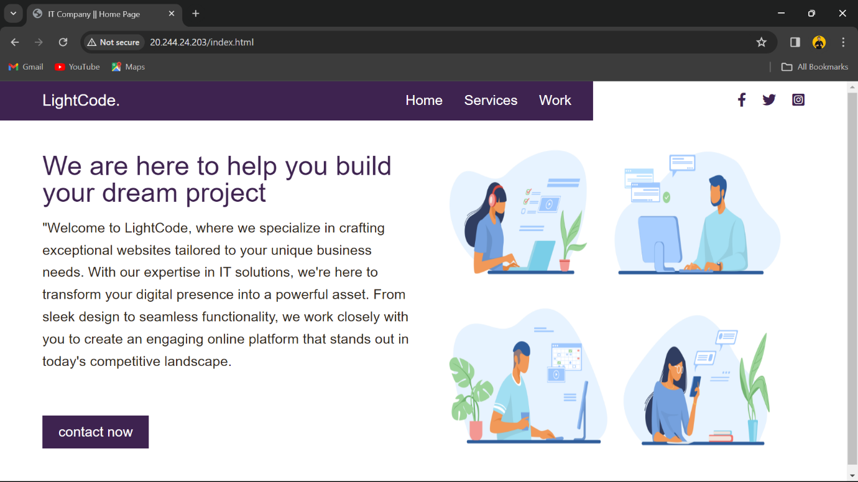

* Contact Page

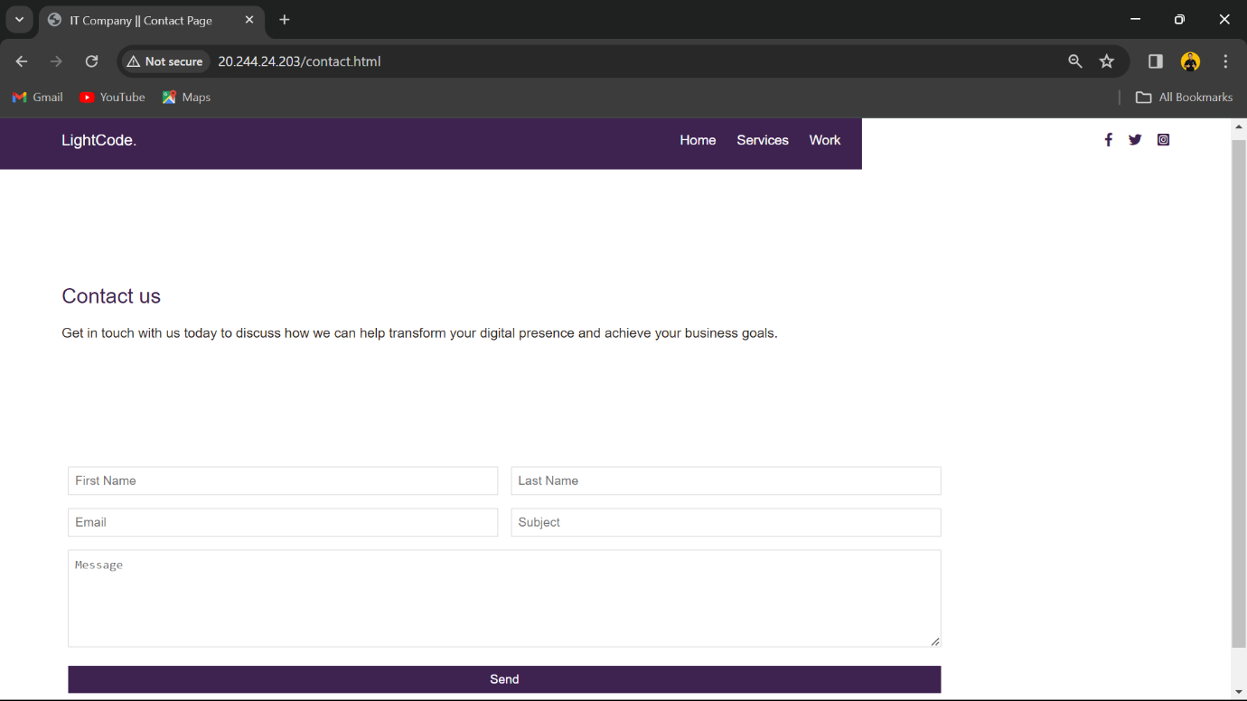

* Service Page

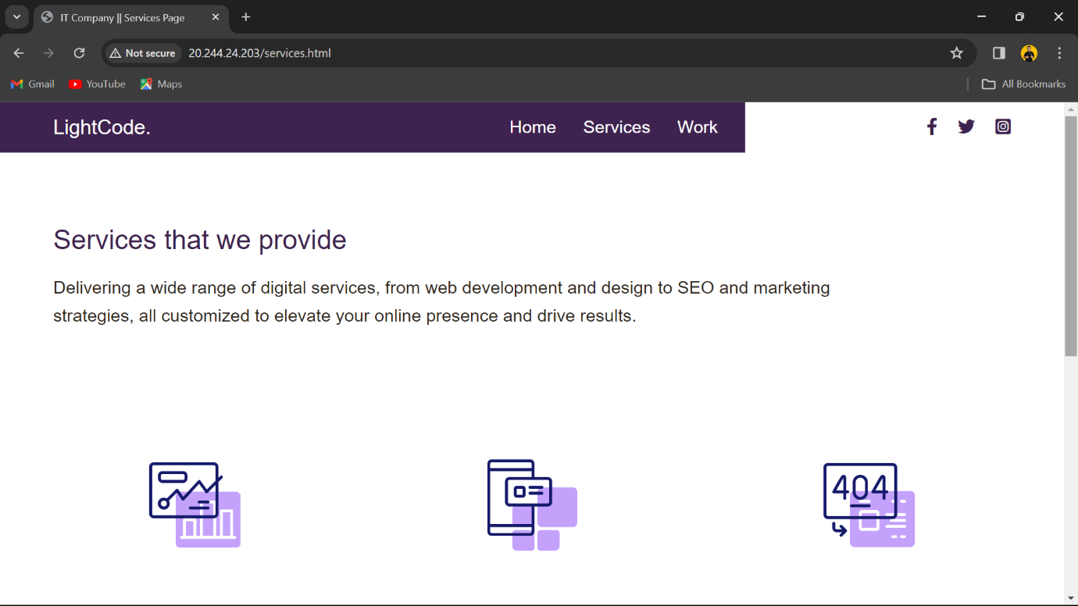

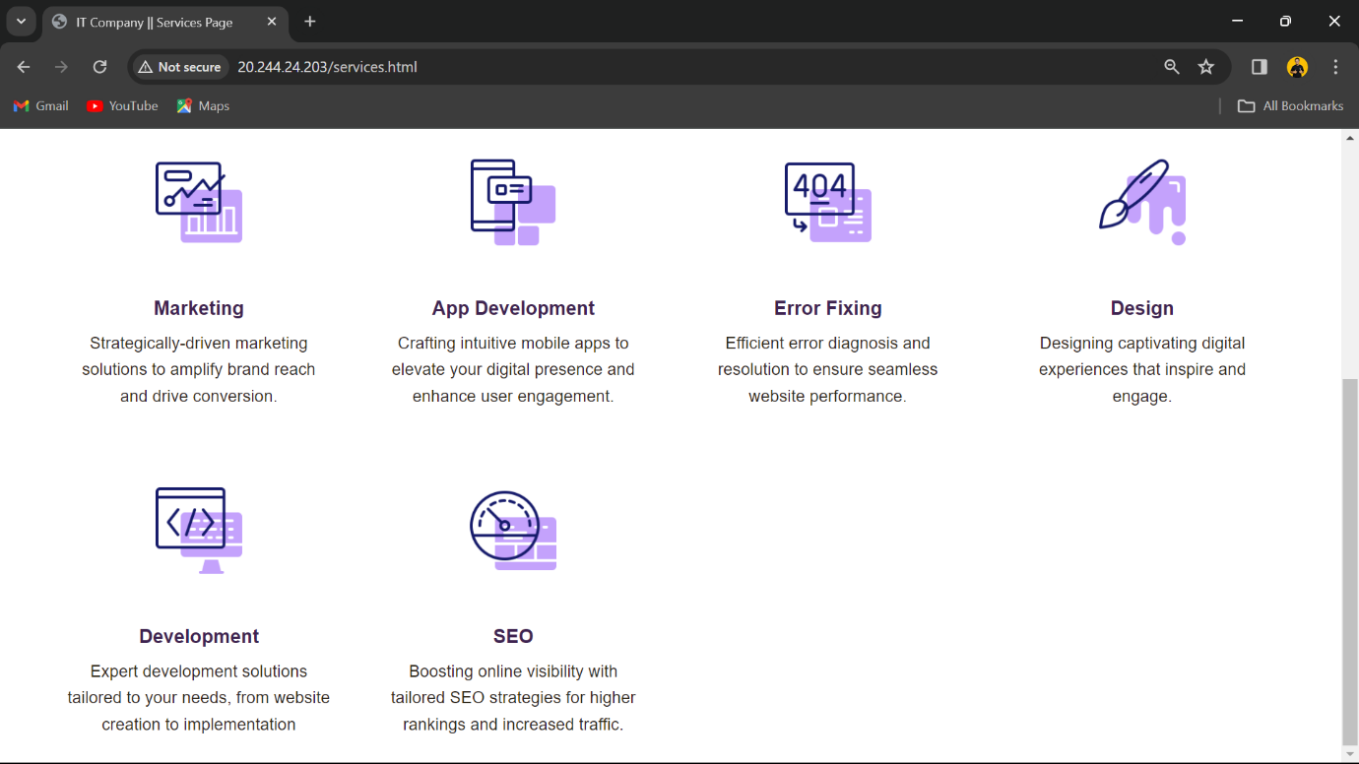

* Work Page

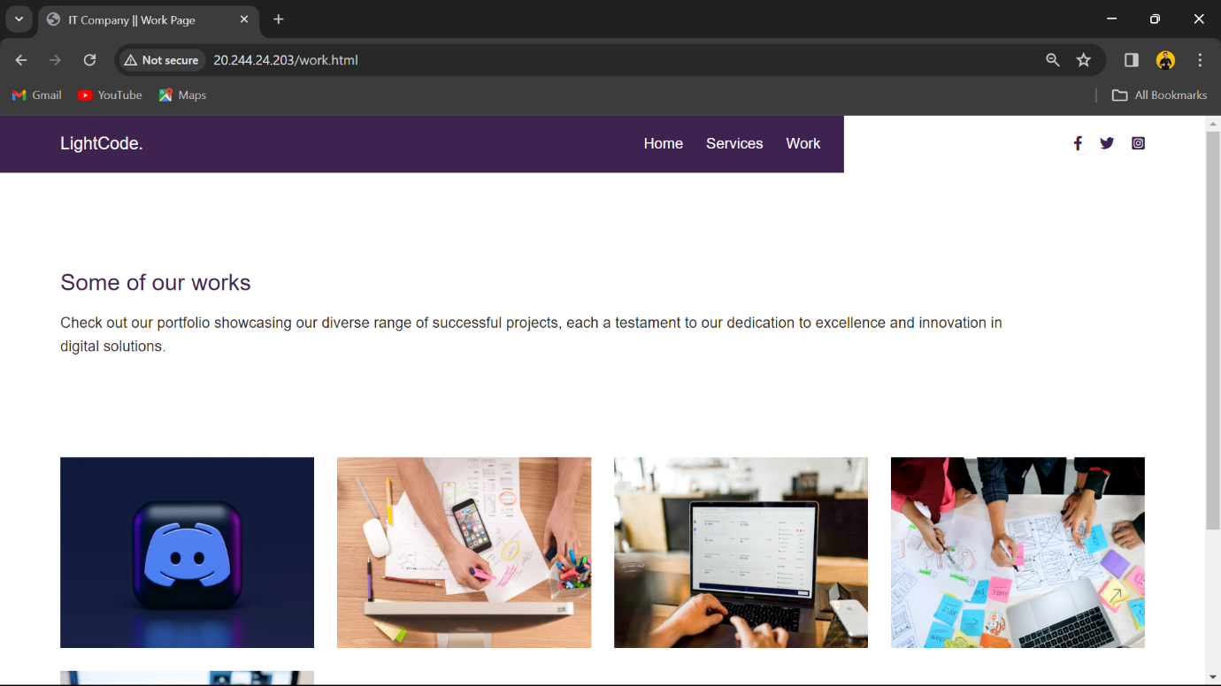

**Conclusion**

In conclusion, the successful completion of the project to create a Virtual Machine (VM) on Microsoft Azure and host a static website has provided stakeholders with a robust and reliable digital presence. Through meticulous planning, implementation, and optimization, we have achieved the objectives outlined at the onset of the project.

The deployment of the Azure VM has enabled us to leverage Microsoft's scalable infrastructure and flexible services to create a stable hosting environment for our static website. By carefully configuring networking settings, installing necessary web server software, and ensuring proper security measures, we have established a secure and accessible platform for hosting our website.

The development of the static website using HTML and CSS has allowed us to craft a visually appealing and user-friendly online presence. Through thoughtful design and optimization techniques, we have created a website that effectively communicates our brand identity and engages visitors with compelling content and intuitive navigation.

Furthermore, the optional configurations implemented, such as custom domain setup and SSL implementation, have enhanced the website's functionality and security. By configuring a custom domain, we have established a memorable and professional web address, while SSL encryption ensures secure communication between users and the website, fostering trust and confidence.

Throughout the project lifecycle, thorough testing, documentation, and training have been conducted to ensure the reliability, performance, and maintainability of the deployed solution. Stakeholders have been equipped with the knowledge and resources necessary to manage and support the hosted website and Azure VM instance effectively.

In summary, the successful deployment of a Virtual Machine on Microsoft Azure and hosting of a static website represents a significant milestone in our digital journey. By leveraging Azure's powerful capabilities and implementing best practices in web development and hosting, we have established a strong foundation for future growth and success in the digital landscape.